Abstract Title (In Uppercase; Font Size 16 pt.; Times New Roman)

Author 1, Author 2, ….. (Put Author Details, Full Name; Font Size 10; Times New Roman)
¹Author Affiliation, ²Affiliation Two, …

Corresponding Author Email: XXXXXXXXXXX

Abstract

Write your abstract here. The abstracts should not be more than 400 words. Please try to restrict your abstract in the same page (including tables, figures, if required). The font style should be 11 pt. with the line spacing of 1. Please upload your abstract in word file. Merge any figure or table using wrap text options.
7th ICTN, 2023, 12-14 Dec etc (ICTN 2023) aims at bringing leading entrepreneurs, researchers, academicians, experts, and students all over the world to share a common platform to present and share recent research investigations, technological advancements, and exchange ideas and global views on the future perspectives and development in the field. The conference will be organized by the Department of Textile Technology, Indian Institute of Technology Delhi, scheduled for 12-14 Dec 2023, at IIT Delhi, New Delhi, India. So come and join us in the ICTN 2023 to explore new research ideas and visions, and look out of the window and discover a whole new city of numerous stories and experiences, be it its heritage, the art and crafts, the diverse cuisine and culture.

References
Put one to three relevant references if required. (Font 10 pt., Time New Roman)

Acknowledgment
Provide the brief acknowledgement (Font 10 pt., Time New Roman)

(See Sample Draft in the Next page)
Smart Textile Actuator using Stress Memory Polymer

Bipin Kumar
Assistant Professor, Department of Textile Technology,
Indian Institute of Technology Delhi, India 110016
bipin@textile.iitd.ac.in

Abstract

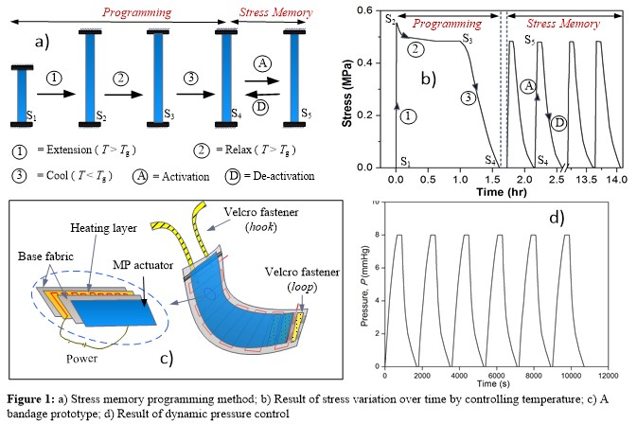
With the rapidly changing needs of consumers over a few decades, textiles are becoming smarter, generating creative and novel solutions for many engineering and medical problems. In this research, a new intelligent function, i.e. stress control, in the textile will be introduced. This novel function of stress control allows programming and storing the internal stress in the structure of textile, and also enabling it to retrieve the stored stress reversibly with an external stimulus such as heat (Figure 1a & 1b). The paper addresses the fundamentals of stress control and the related mechanism using a viscoelastic model consists of spring and dashpot elements. As an example of the potential application, the stress control in textile can be used for smart medical compression treatment to allow pressure control with massaging effect for an efficient treatment of compression therapy used in chronic venous disorders (Figure 1c & 1d). It is anticipated that the research into stress control in textiles will grow in multiple dimensions as a result of their promising potential in many stress controlling applications such as pressure garments, bandages, massage devices, 3D mattress, sensors , actuators, etc.

References
- Narayana, H., Hu, J., Kumar, B., Shang, S., Han, J., Liu, P., Lin, T., Ji, F.L., Zhu, Y. (2017): Stress-memory polymeric filaments for advanced compression therapy. Journal of Materials Chemistry B, 5 (10), 1905-1916
- Kumar, B., Hu, J., Pan, N., Narayana, H. (2016): Investigation and designing of an orthopaedics device using stress memory actuator for smart compression. Materials and Design, 97, pp. 222-29.
- Kumar, B., Hu, J., Pan, N. (2016): Smart medical stocking using memory polymer for chronic venous disorders. Biomaterials,75, pp. 174–181

Acknowledgment
The author acknowledges the financial support received from the Department of Science & Technology (DST), India (Project Code: MI01567).

